|  |
| --- |
| [Moster_G] |
| The King of Steal |
| **[**Rescue a princess] |
| Version #1.2  All work Copyright © 2016 by Monster_G.  All rights reserved. |
| **[Giho Kim #300738697]** |
| **Giho Kim** |



|  |
| --- |
| Jan 29th 2016 |

**Table of Contents**

1. **Version History**
2. **Captured image (intro)**
3. **Game Information**
4. **Game Overview**
5. **Menu and Screen Descriptions**
6. **Game World**
7. **Levels**
8. **Characters**
9. **Enemies**
10. **Sound Index**
11. **Story Index**
12. **Design Notes**
13. **Future Features**
14. **Version History**

|  |  |
| --- | --- |
| **Version** | **Description** |
| 0.1 | Initial draft of document |
| 1.0 | Final document (before review) |
| 1.1 | Modified |
| 1.2 | Final document |

1. **Captured image**

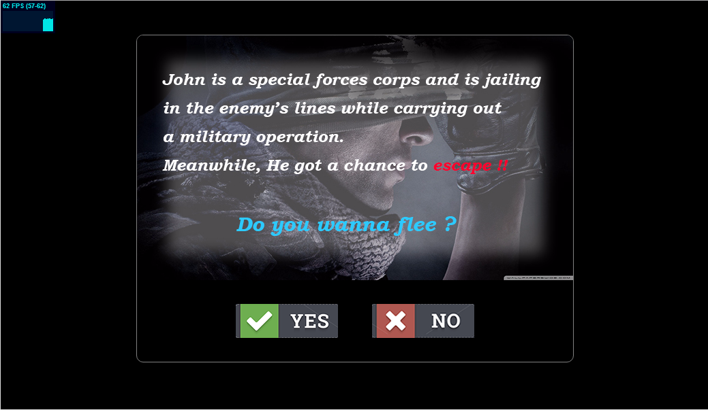

1. **Game Overview**

*A user can win ones he gets a safe way which should overcome various obstacle in terms of the enemy attack. The user should find the way to escape from the enemy.*

1. **Menu and Screen Descriptions**

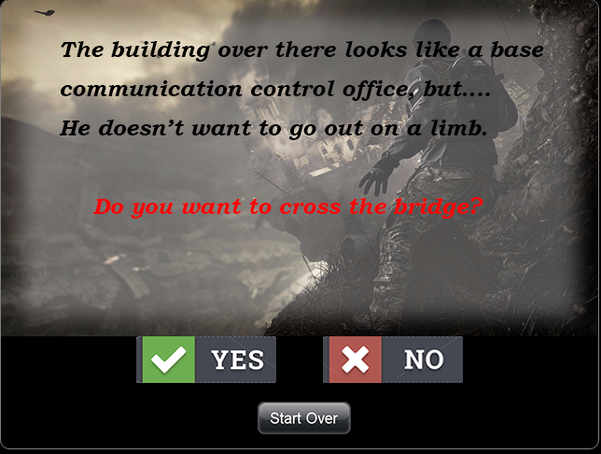

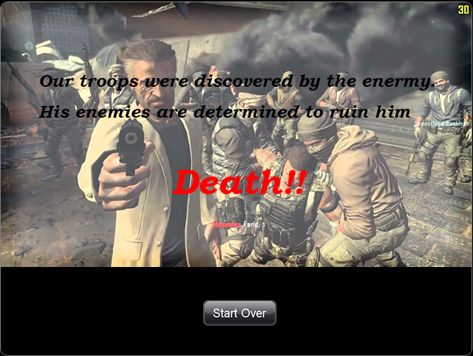

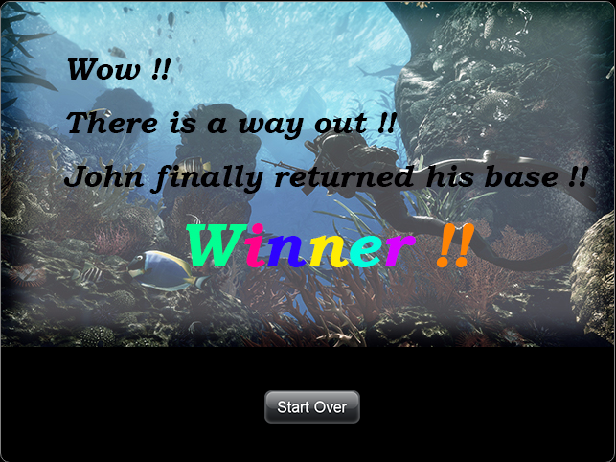

1. **Game World**

|  |  |
| --- | --- |
| CPU | 1 GHz processor |
| RAM | 2 GB RAM |
| HDD | 5 GB available hard disk space |
| Video | Geforce GT 500 |
| DirectX | v9.0c or better |
| Operation System | Windows XP (Service Pack 2 or 3 ONLY), Windows 7,8 or 10 |

1. **Levels**

*Level2 – User can choose 2 ways from intro whether escape from the prison or not.  
Level3 – There are a lot of situations and user can choose one of the ways.*

*Level4 – User can achieve goal as one positive and seven negative ways.*

1. **Characters**

*John: He is a special troops and went an enemy base to get information such as drug trafficking and arms dealing.*

1. **Non-player Characters**

*Rescue team: They are come from the john’s troop and try to rescue him.*

1. **Enemies**

*Enemy: They are soldiers and armed and dangerous*

1. **Sound Index**
2. *I choose a music for background.*
3. *I had put the sound effects based on the story.*
4. **Story Index**
5. *This game is to escape from the enemies and user faces a lot of story.*
6. *A user can choose Yes or No base on the story.*
7. *To survive, user have to find the best way on the game*
8. *No body know which story can be happened.*
9. **Future Features**

Field: We will expand areas where a player can experience various missions which will be given.

Character: More characters will be provided because there is only one character can be selected to play for now.